AI-Driven Business Innovation
  - Strategic Frameworks for AI Investment Decisions
Dr. Michael Borck | Curtin University
2025-11-05

Companion Site
Scan QR code for quick access to digital materials:


The Question We’ll Answer
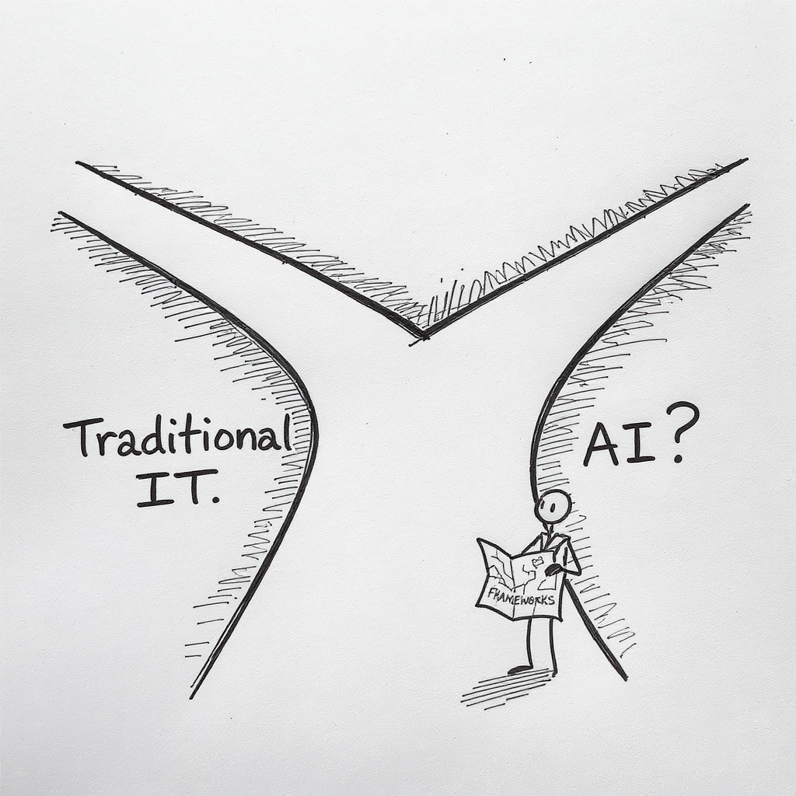
How is evaluating AI investments DIFFERENT from traditional IT investments?
By end of day, you’ll know:
- 5 ways AI differs from traditional IT
- 5 AI-specific evaluation criteria
- Why highest ROI ≠ best AI investment

Today’s Schedule
Morning Session:
- What Makes AI Different
- Exercise 1: AI Tech Radar
- Strategic Frameworks
- Exercise 2: AI-Assisted Strategic Analysis
Afternoon Session:
- AI Investment Model
- Exercise 3: Dragon’s Den
- Exercise 4: Strategic Response Scenarios
- Debrief & Action Planning

Traditional vs. AI
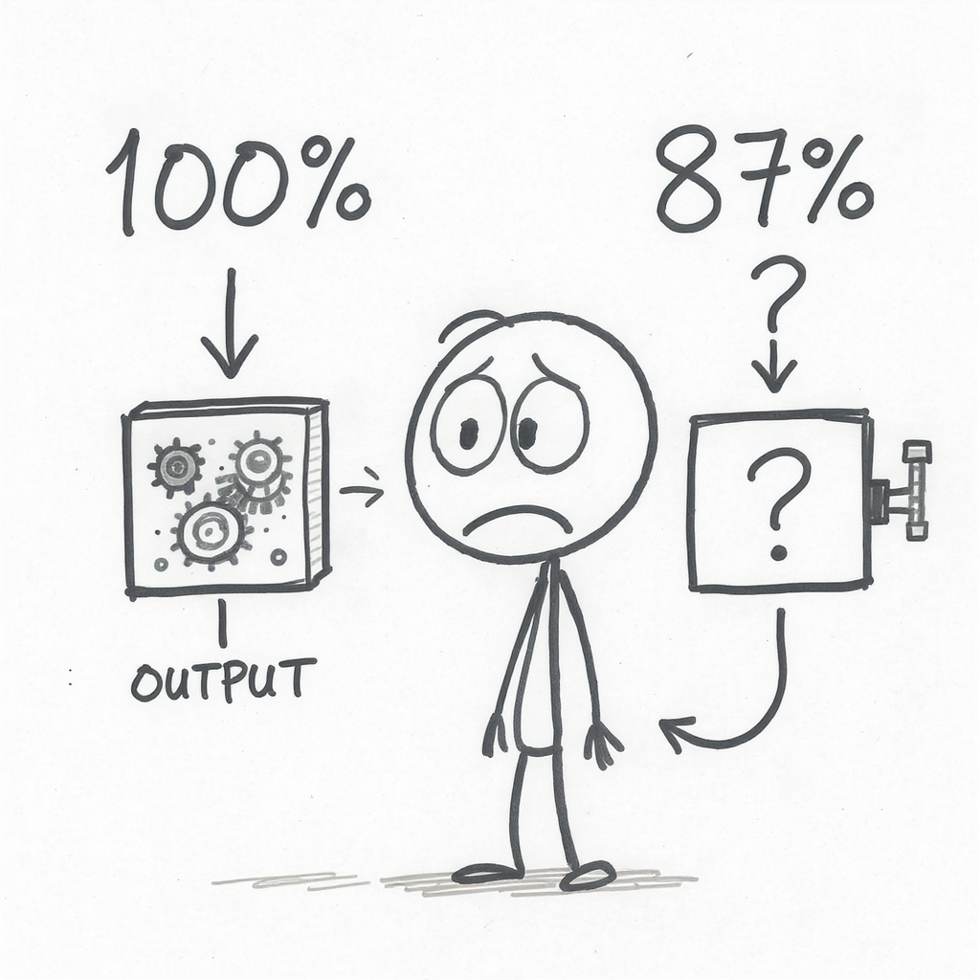
Traditional IT | AI
Deterministic | Probabilistic
Works without data | Useless without data
Build once, maintain | Continuous learning
Traceable decisions | Black box
Human bias | Amplified bias at scale
Implication: AI needs DIFFERENT evaluation criteria

1. Data Dependency
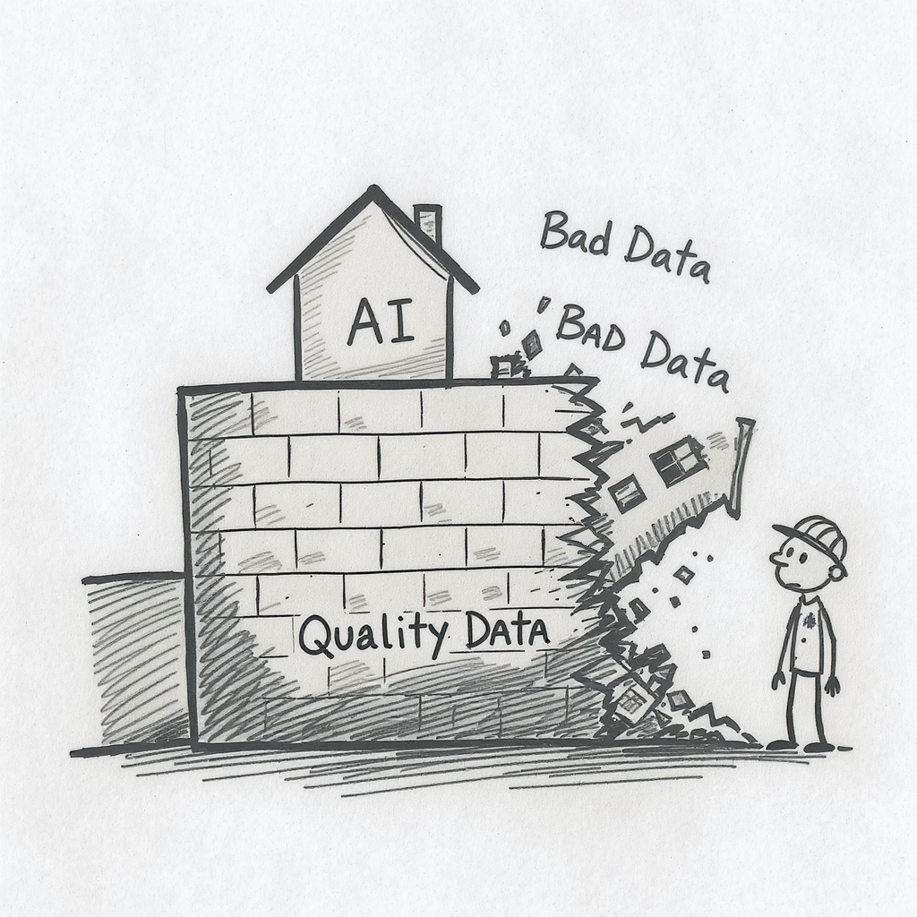
Traditional IT:
- Write code based on business rules
- Works regardless of data quality
AI:
- Learns patterns from historical data
- Quality = Data Quality × Algorithm
Before funding AI: Assess data readiness (0-10 score, need 7+)

2. Continuous Learning
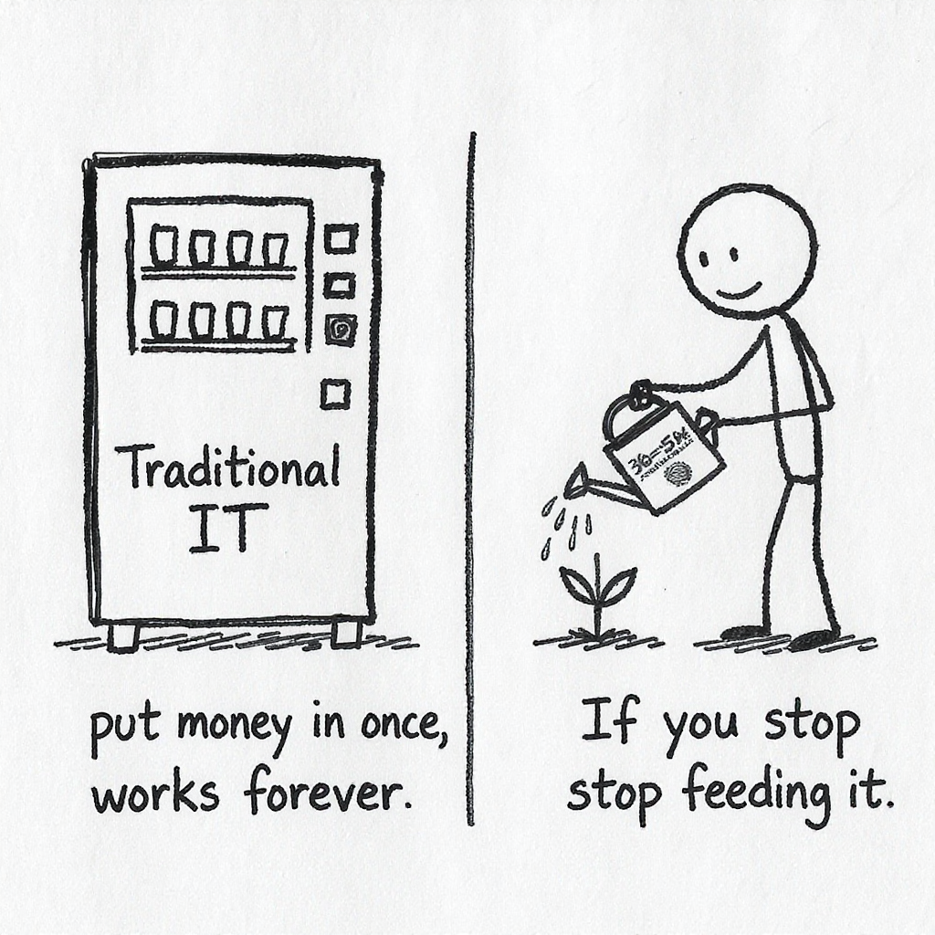
Traditional IT:
- Build once, maintain 10-15% annually
- Predictable costs
AI:
- Continuous retraining as world changes
- Ongoing costs: 30-50% annually
Calculate 5-year TCO, not just Year 1 cost

3. Probabilistic Nature
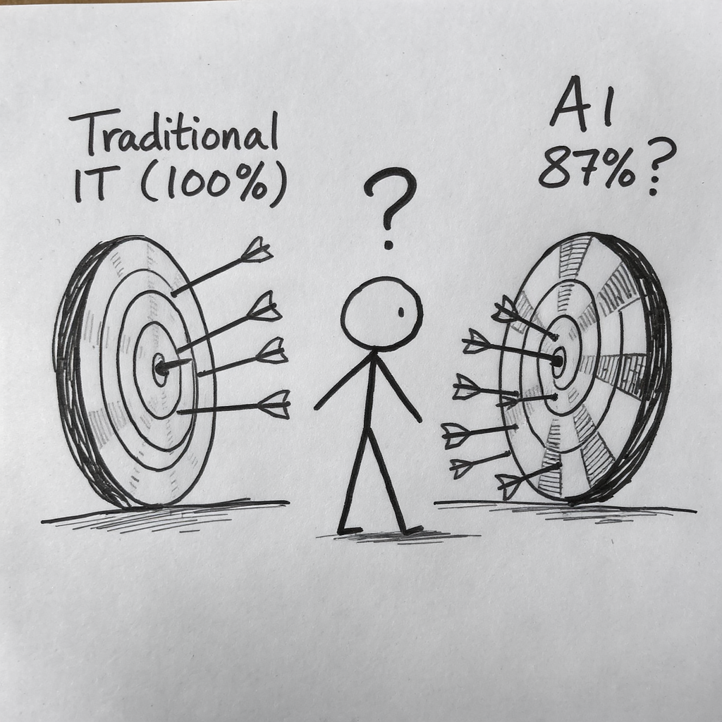
Traditional IT: Same input = same output (100%)
AI: “I’m 87% confident customer will churn”
Match AI accuracy to business risk tolerance:
- Low stakes (recommendations): 70-80% OK
- Medium stakes (operations): 85-95% needed
- High stakes (medical, financial): 95-99%+ required

4. Black Box Problem
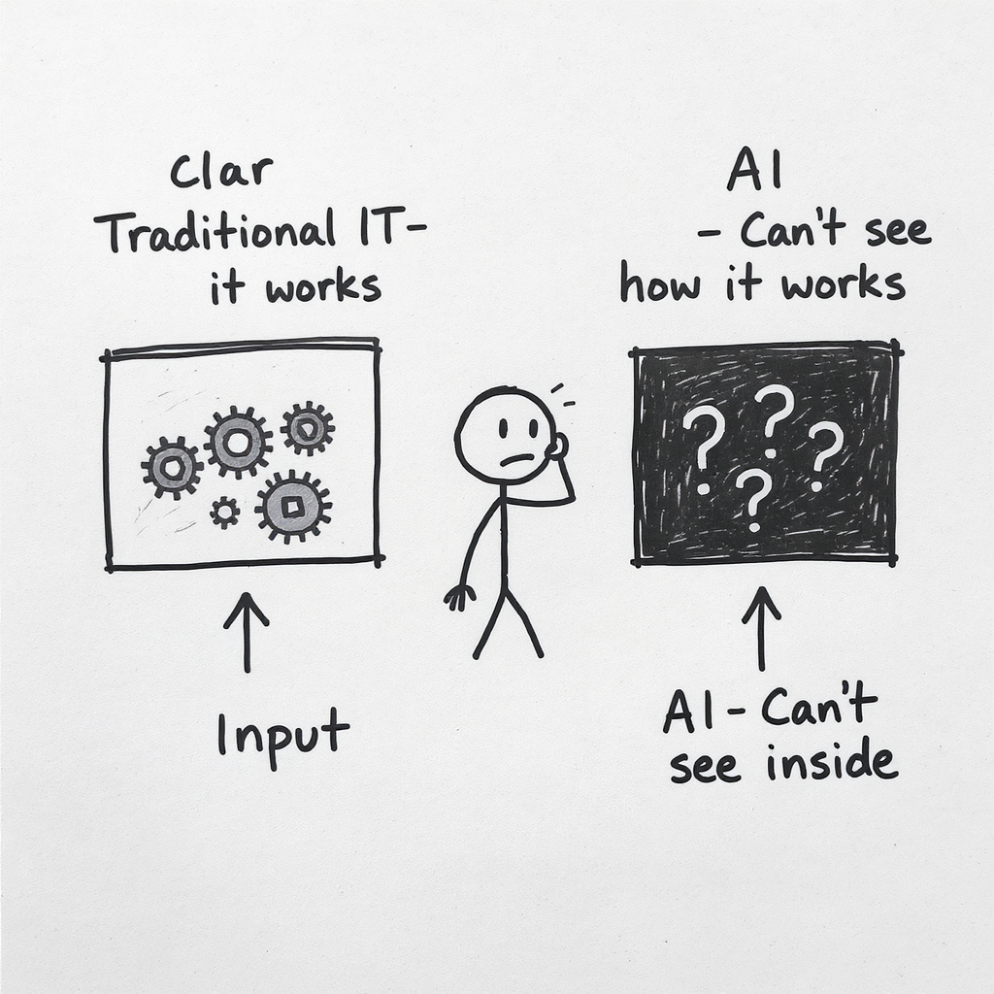
Traditional IT:
- Trace every decision
- Developers explain “why”
AI (especially deep learning):
- Input → Black Box → Output
- “The model learned that pattern”
High explainability = Limited algorithms + Higher cost (+15-20%)

5. Ethical & Bias Risk
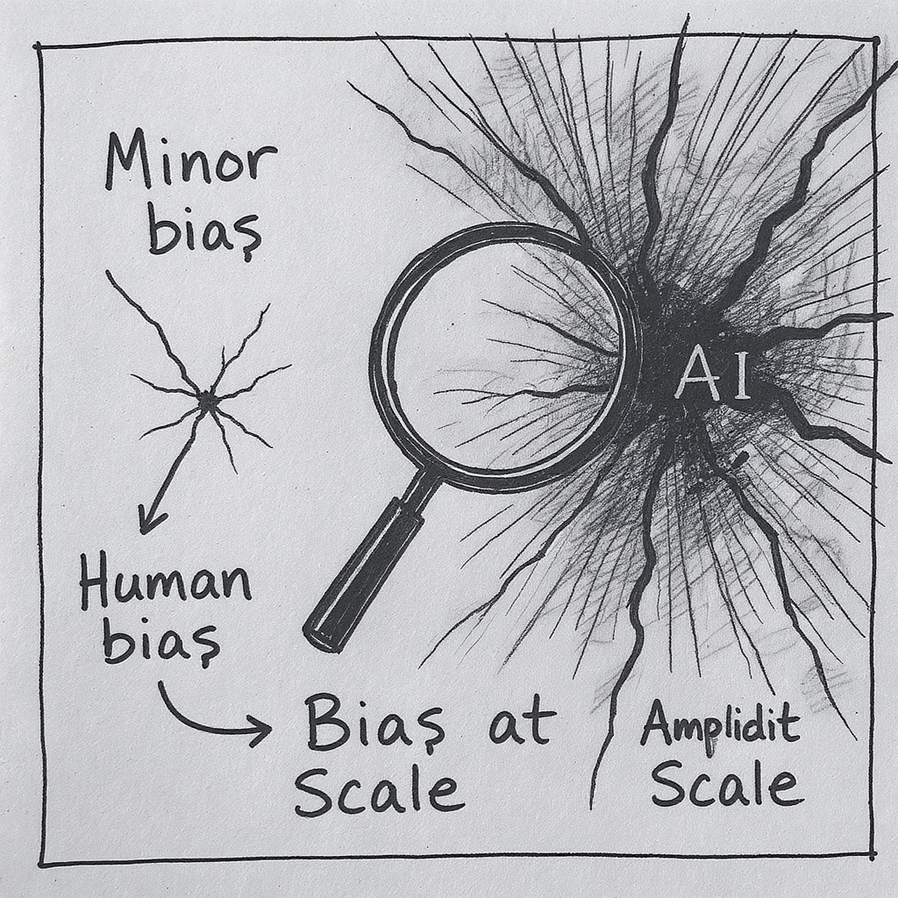
Traditional IT:
- Human biases, limited scale
AI:
- Learns biases from historical data
- Applies at massive scale
- Hidden in model
One biased AI = Millions of biased decisions
Budget 10-30% for bias testing, diverse teams, monitoring

The 5 AI-Specific Criteria
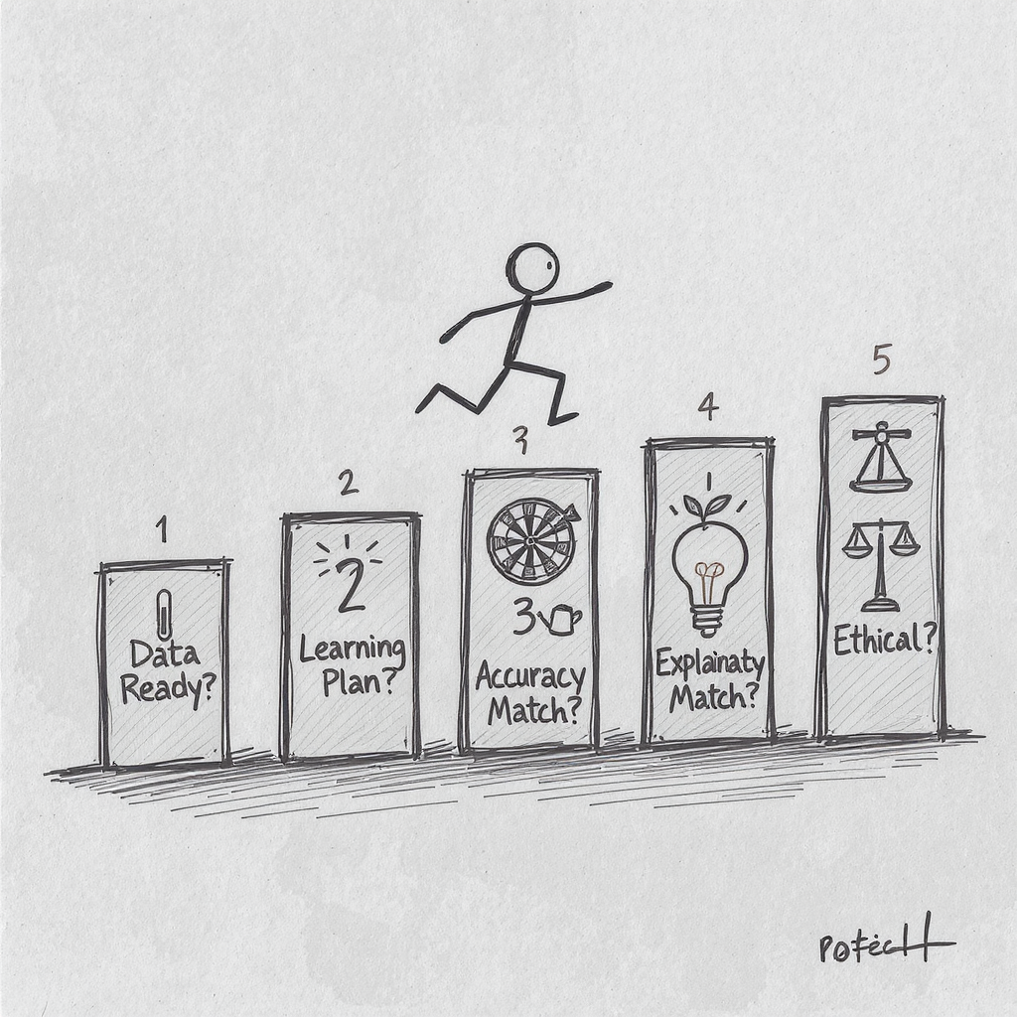
Every AI investment must answer:
- Data Readiness - Score 0-10, need ≥7?
- Continuous Learning - 30-50% ongoing cost budgeted?
- Accuracy vs. Risk - Does AI capability match requirements?
- Explainability - Can we explain decisions (if required)?
- Ethical Risk - Have we tested for bias?
Must pass BOTH traditional AND AI-specific criteria

Framework 1: AI Transformation Matrix
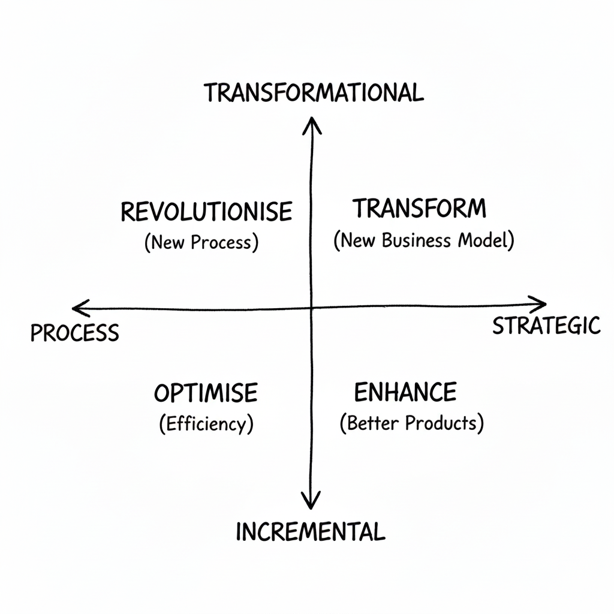
Four Quadrants of AI Impact:
Classify AI initiatives:
- OPTIMIZE (Process + Incremental): Efficiency
- ENHANCE (Strategic + Incremental): Better products
- REVOLUTIONIZE (Process + Transformational): New processes
- TRANSFORM (Strategic + Transformational): New business models
Most organizations: 80% in OPTIMIZE quadrant
Use: Identify portfolio balance and gaps
- The Innovation Adoption Framework provides a roadmap for implementing AI in organisations
- Phase 1 is Knowledge Building - understanding what’s possible before making commitments
- Phase 2 is Strategic Alignment - connecting AI initiatives to specific business objectives
- Phase 3 is Capability Development - building or acquiring the needed skills and technologies
- Phase 4 is Pilot Implementation - testing in controlled environments to demonstrate value
- Phase 5 is Organisational Transformation - scaling successful approaches across the business
- The Digital Agriculture Services example illustrates this progression
- They began by building knowledge about how satellite imagery and ML could predict crop yields
- They aligned this with strategic business needs in agricultural insurance and investment
- They developed capabilities by building data science teams and satellite imagery processing
- Their pilot implementations tested predictions against ground-truth data in specific regions
- Now they’re transforming the agricultural intelligence landscape at organisational scale
- This framework applies to any significant innovation initiative, not just AI
- The key insight: skipping phases often leads to implementation failure
- Many organisations jump straight to pilots without strategic alignment or capability building
- The KPMG framework provides additional detail on implementing each phase
- What phase is your organisation currently in? Are you trying to skip essential steps?

Framework 2: Data Value Pyramid
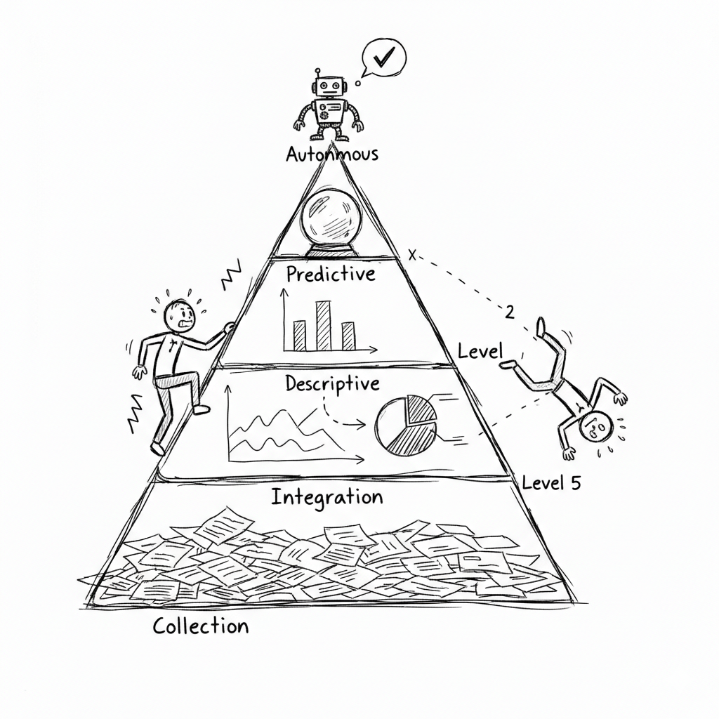
5 Levels of Data Maturity:
- Level 5: AUTONOMOUS - AI decides and acts
- Level 4: PREDICTIVE - Forecast what will happen
- Level 3: DESCRIPTIVE - Understand what happened
- Level 2: INTEGRATION - Connect data sources
- Level 1: COLLECTION - Gather raw data
You cannot skip levels

Match AI to Data Maturity
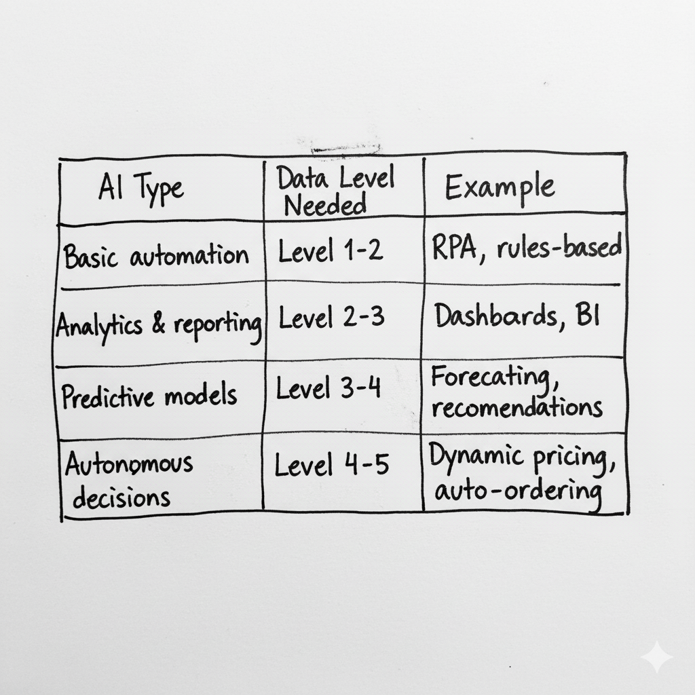
AI Type | Data Level Needed | Example
Basic automation | Level 1-2 | RPA, rules-based
Analytics & reporting | Level 2-3 | Dashboards, BI
Predictive models | Level 3-4 | Forecasting, recommendations
Autonomous decisions | Level 4-5 | Dynamic pricing, auto-ordering
Assess data maturity BEFORE funding AI

Why 85% of AI projects fail
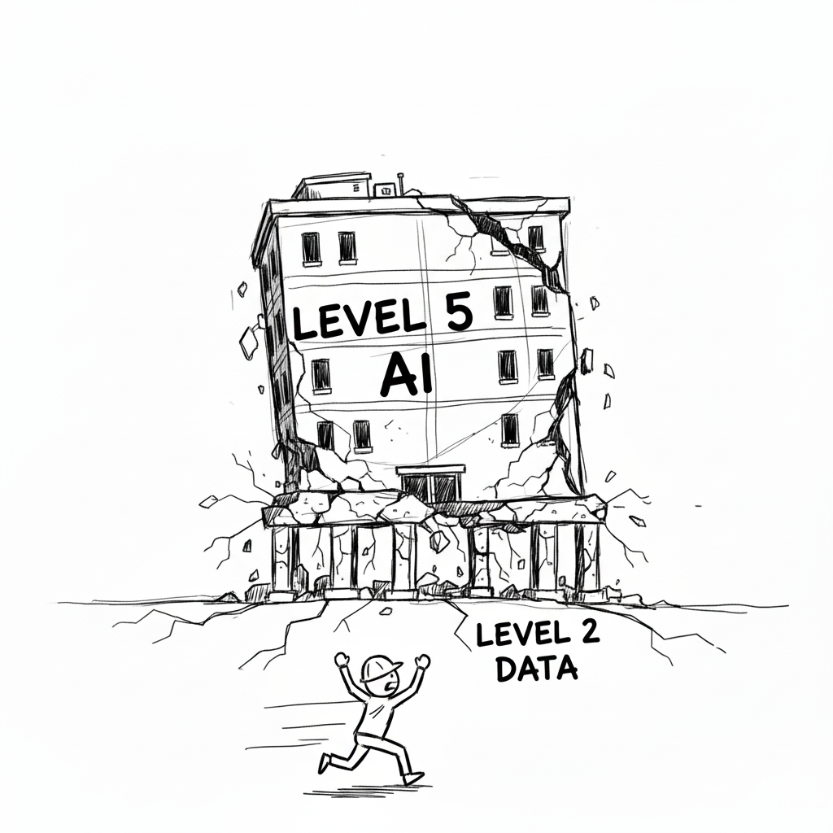
If you’re at Level 2, you cannot do Level 5 AI
You will fail.
Most organizations:
- Current state: Level 2-3
- AI ambition: Level 5
- Gap = Why 85% of AI projects fail

Exercise 1: AI Tech Radar
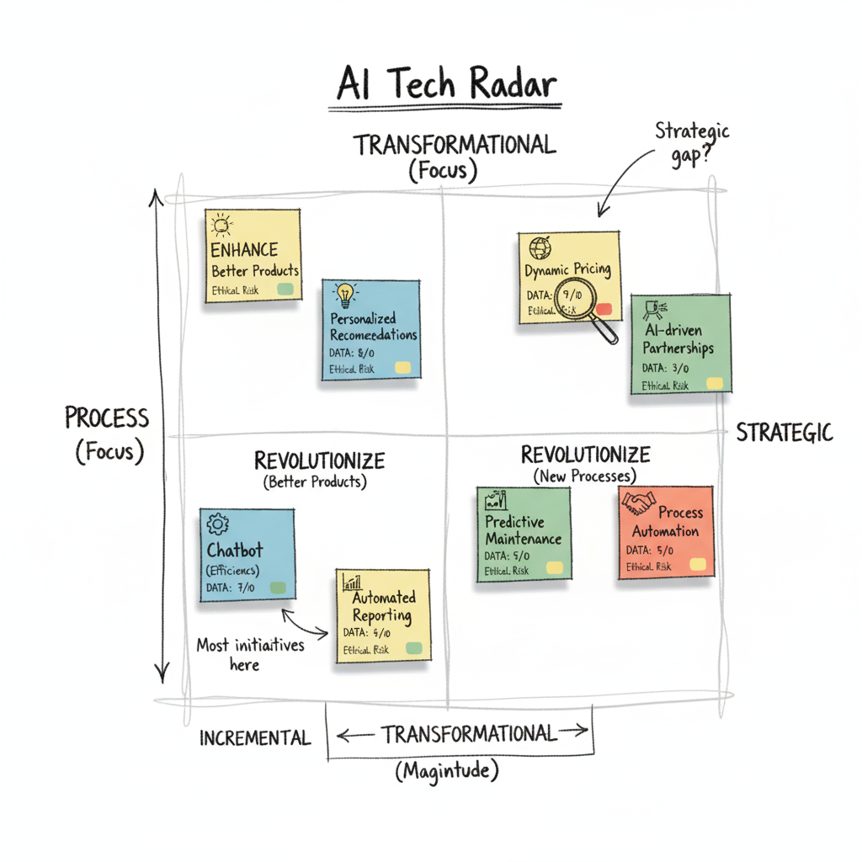
Your Task (in table groups):
- Map AI capabilities on Transformation Matrix
- Assess data readiness for each (0-10 score)
- Flag ethical risks (HIGH/MED/LOW)
Output: Where are you today? Where are gaps?

Break


Framework 3: Three Horizons Model
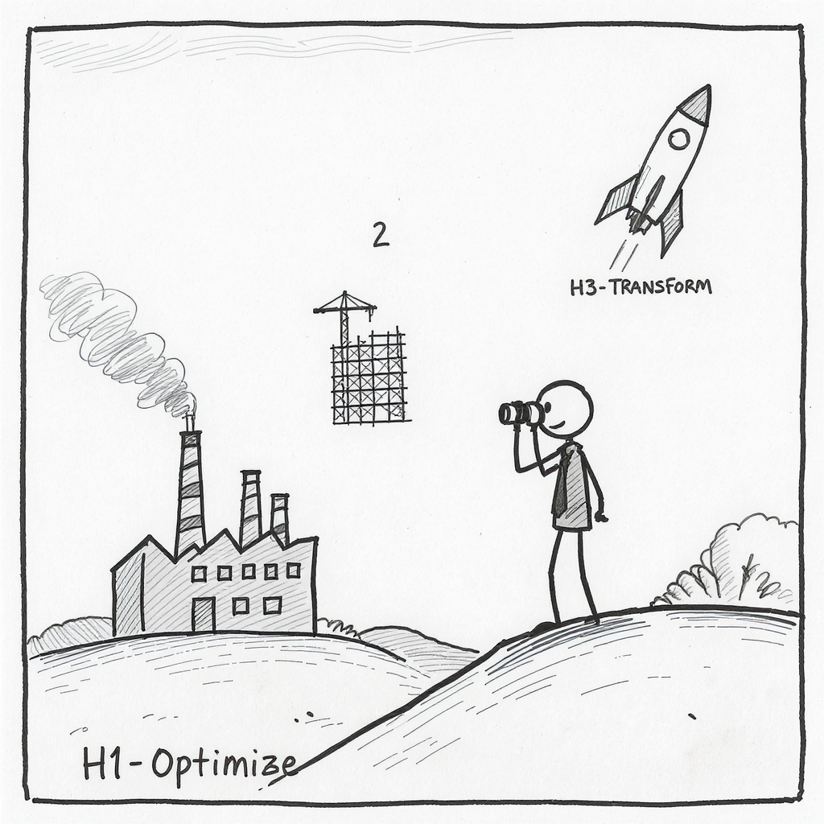
Balance AI portfolio across timeframes:
- Horizon 1 (0-12 mo): Optimize core - 70% of budget
- Horizon 2 (1-3 yrs): Build emerging - 20% of budget
- Horizon 3 (3-5+ yrs): Create future - 10% of budget
All H1 = No future | All H3 = No present

Portfolio Balance
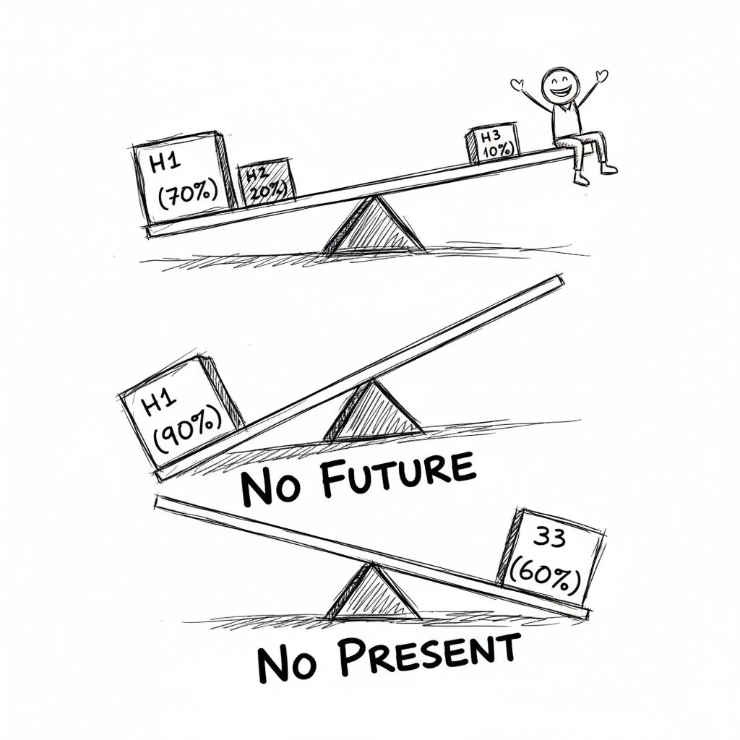
Most organisations get this wrong:
- All H1 (80%+ optimize): Efficient today, irrelevant tomorrow
- All H3 (50%+ moonshots): Exciting vision, no cash flow
Right balance: 70/20/10
Audit your AI portfolio: Are you balanced?

Framework 4: Innovation Adoption Framework
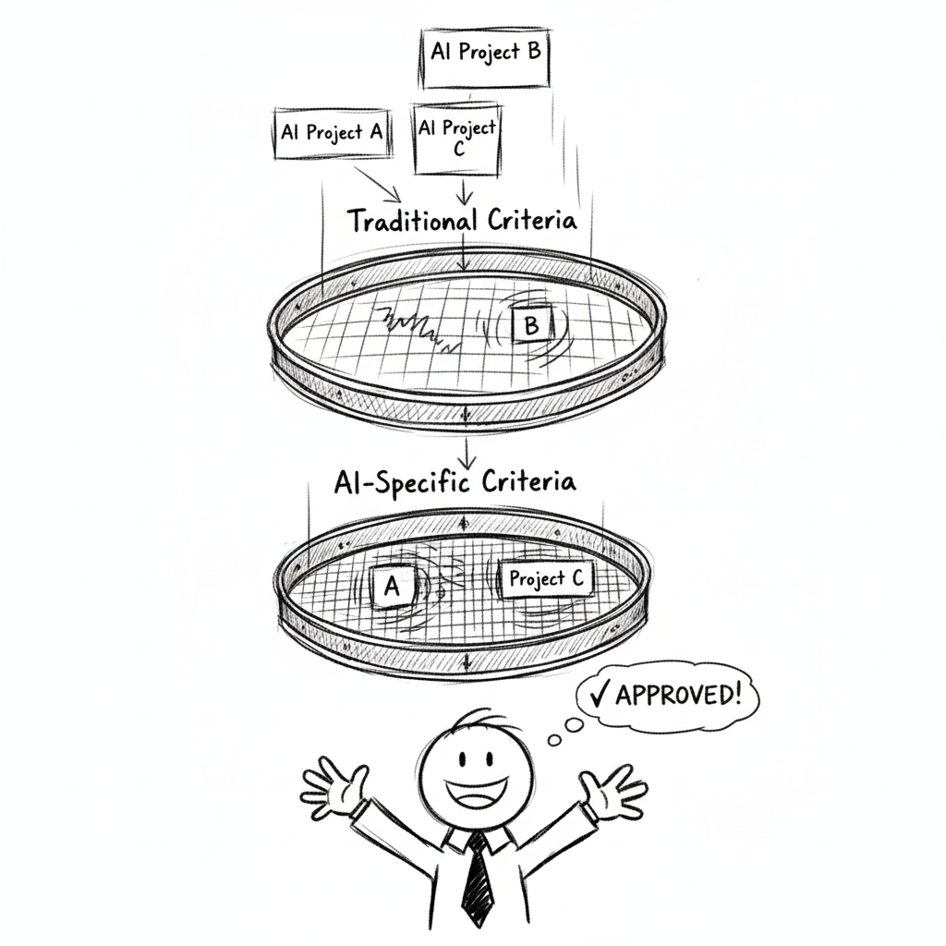
Even great AI initiatives fail if people don’t adopt them
- Technical feasibility ✓
- Strong business case ✓
- But: 70% of digital transformation fails due to people resistance
Must assess organizational readiness BEFORE investing

The 5 Adoption Barriers
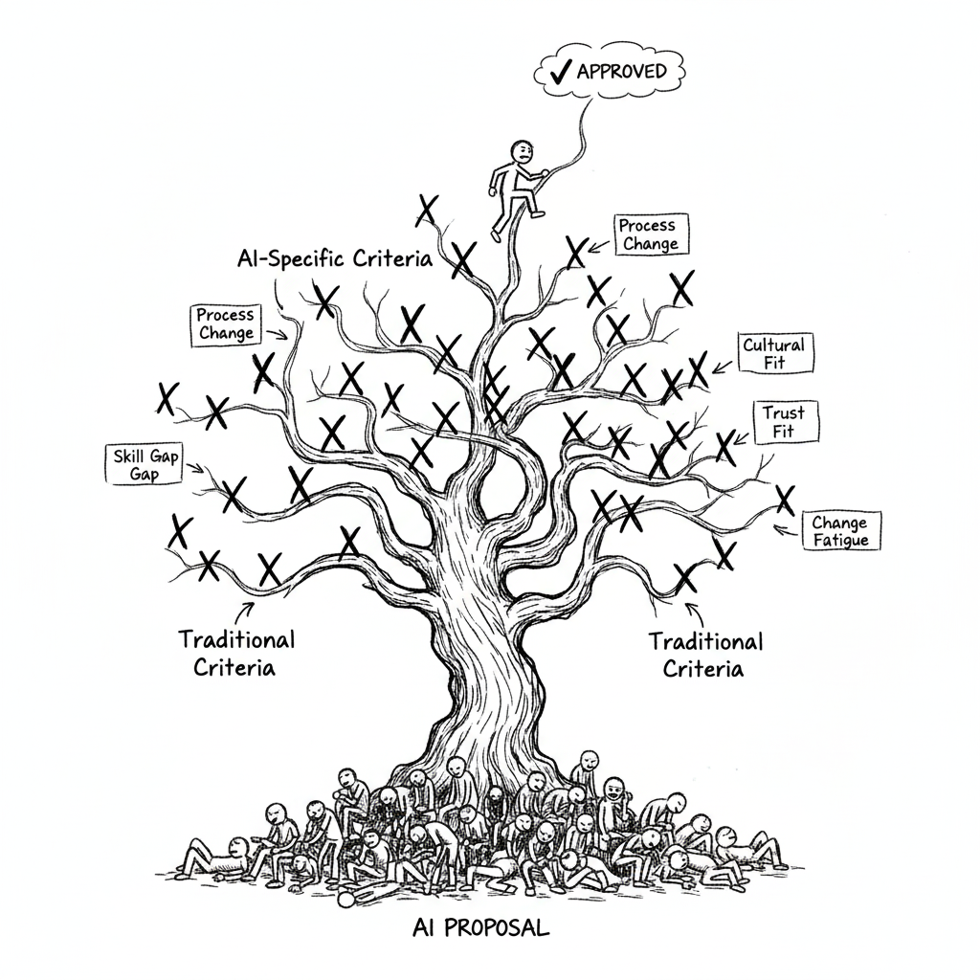
Every AI initiative faces resistance:
- Skill Gap - Do people have required capabilities?
- Process Change - How much disruption to workflows?
- Cultural Fit - Does it align with organizational values?
- Trust - Do people believe in the technology?
- Change Fatigue - Are people exhausted from prior changes?

Adoption Readiness Assessment
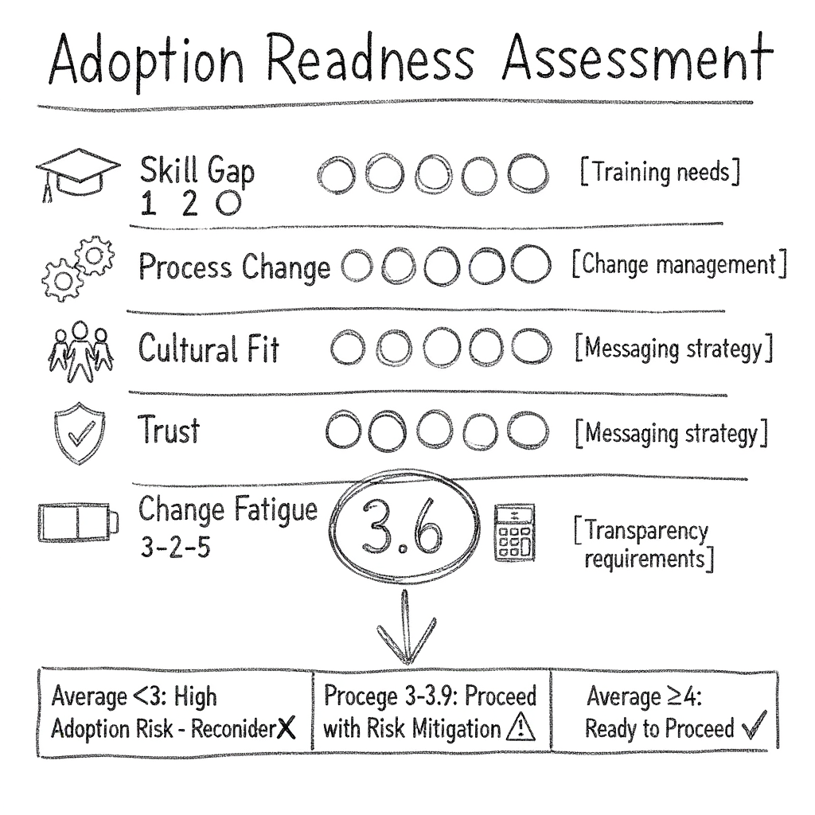
Score each barrier 1-5 (5 = low barrier, 1 = high barrier):
Barrier | Score | Impact
Skill Gap | ___ | Training needs
Process Change | ___ | Change management
Cultural Fit | ___ | Messaging strategy
Trust | ___ | Transparency requirements
Change Fatigue | ___ | Timing decision
- Average ≥4: Ready to proceed
- Average 3-3.9: Proceed with risk mitigation
- Average <3: High adoption risk, reconsider

Exercise 2: AI-Assisted Strategic Analysis
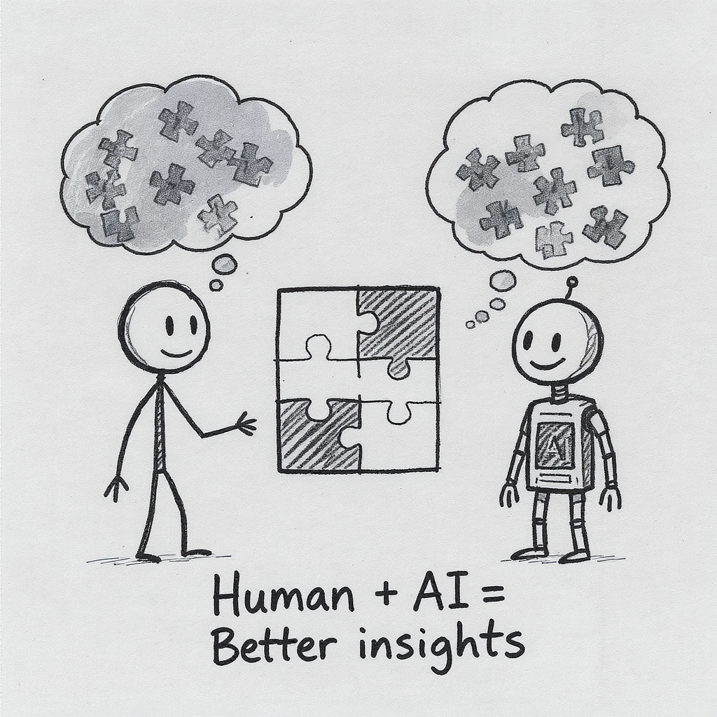
Round 1: Risk Deep-Dive AI identifies threats you missed
Round 2: Reverse Prompting AI asks YOU questions to reveal opportunities
Round 3: AI Debate Two AIs argue different perspectives
You’ll use AI tools (ChatGPT/Claude/Gemini) for strategic thinking
Three phases:
- Human Brainstorm - Your thinking first
- AI Augmentation - Use AI to go deeper
- Human Synthesis - Compare & learn

Lunch


Framework 5: AI Investment Model
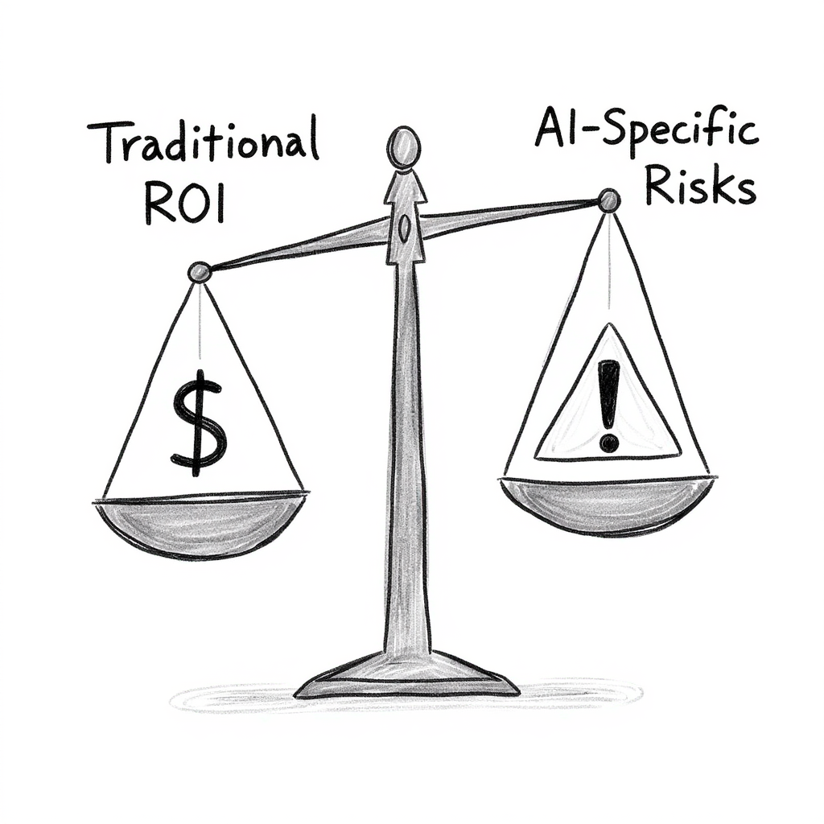
Two-part evaluation:
Part A: Traditional Criteria
- Strategic fit (Three Horizons, Transformation Matrix)
- Financial ROI (4 value categories)
- Implementation feasibility
Part B: AI-Specific Criteria
- Data readiness (0-10 score)
- Continuous learning plan
- Accuracy vs. risk tolerance
- Explainability requirements
- Ethical risk assessment

The 4 Value Categories
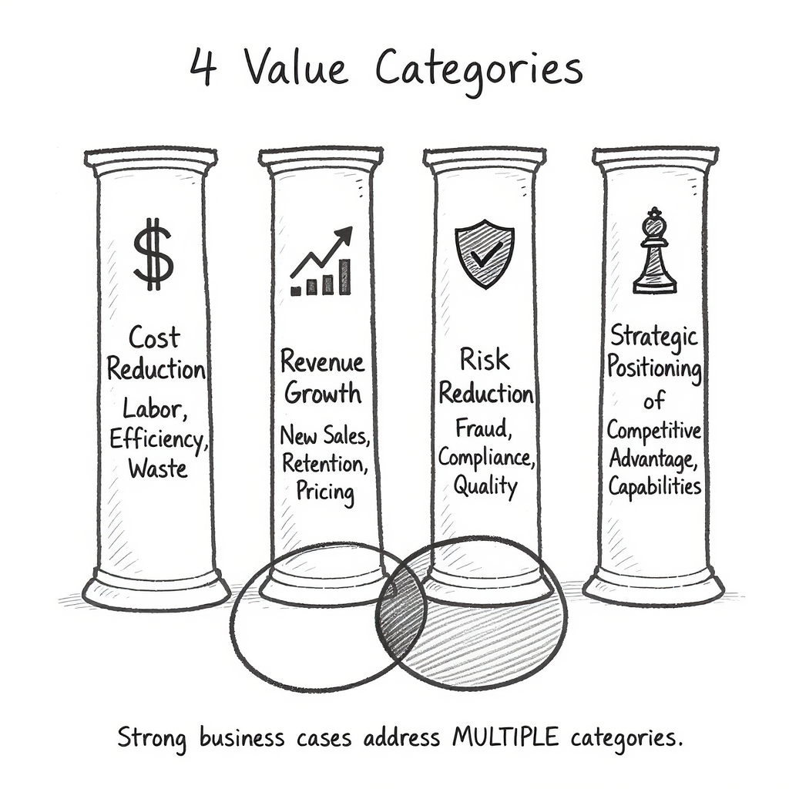
Every AI investment creates value across:
- Cost Reduction - Labor, efficiency, waste
- Revenue Growth - New sales, retention, pricing
- Risk Reduction - Fraud, compliance, quality
- Strategic Positioning - Competitive advantage, capabilities
Strong business cases address MULTIPLE categories

AI-Specific: The 5 Criteria
1. Data Readiness (0-10)
- Data availability, quality, access, bias
- If <7: Stop, fund data infrastructure first
2. Continuous Learning (TCO)
- Static (10-15%), Batch (25-30%), Real-time (35-50%)
- Calculate 5-year TCO, not just Year 1
3. Accuracy vs. Risk Tolerance
- Low stakes: 70-80% OK
- Medium: 85-95% needed
- High: 95-99%+ required
4. Explainability
- HIGH (regulated): Interpretable models only (+15-20%)
- MEDIUM (operational): Add explanation tools (+10-15%)
- LOW (consumer): Any algorithm OK
5. Ethical Risk Assessment
- HIGH (life-impacting): Extensive testing (+20-30%)
- MEDIUM (customer-facing): Bias testing (+10-15%)
- LOW (internal): Basic review (+5%)
Budget for bias testing, diverse teams, monitoring

The Strategic Dilemma
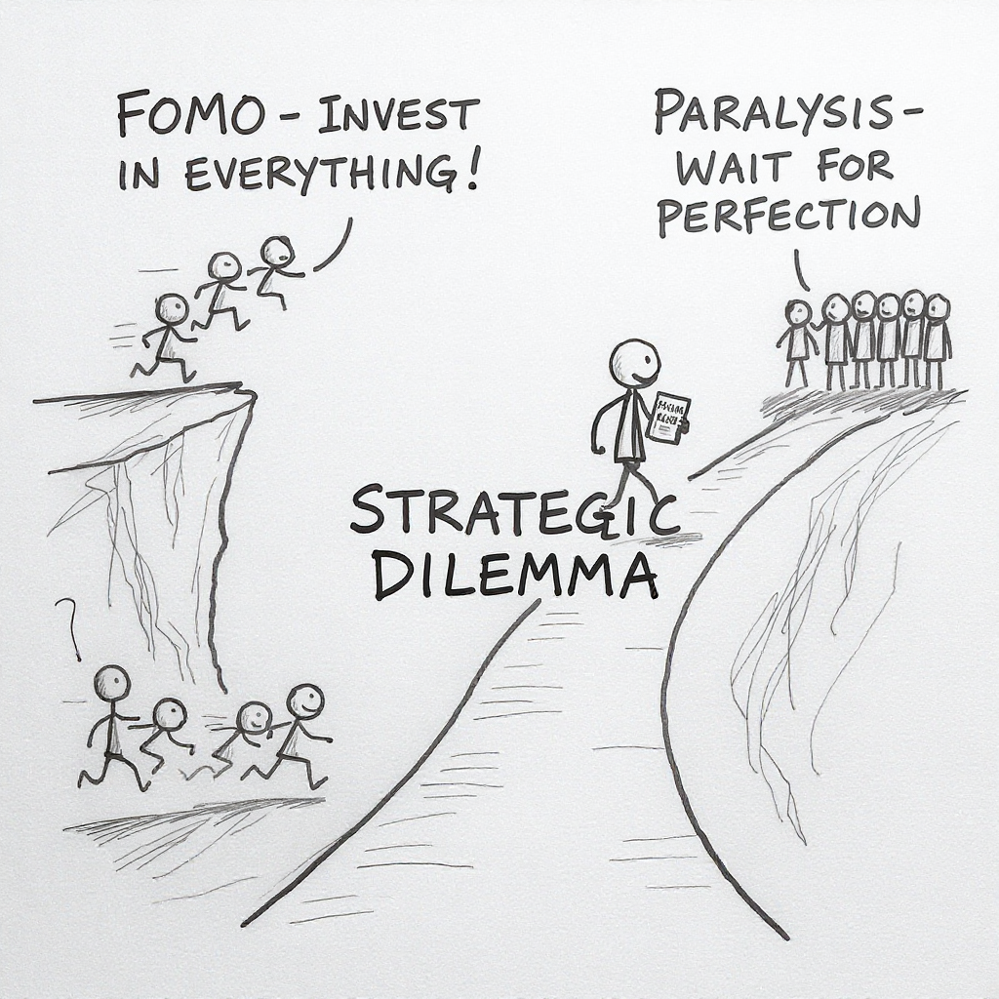
If you used ONLY traditional ROI:
- Fraud Detection: 315% ROI ← Fund this
- Inventory: 264% ROI ← Fund this
- Dynamic Pricing: 253% ROI ← Maybe this?
- Chatbot: 92% ROI ← Don’t fund
But after AI-specific analysis:
- Fraud: Data not ready (need 6 months prep first)
- Inventory: Exceeds budget cap
- Dynamic Pricing: HIGH ethical/bias risk
- Chatbot: Only one that’s truly ready ✅
Traditional criteria would fund the WRONG projects

Break

Exercise 3: Dragon’s Den
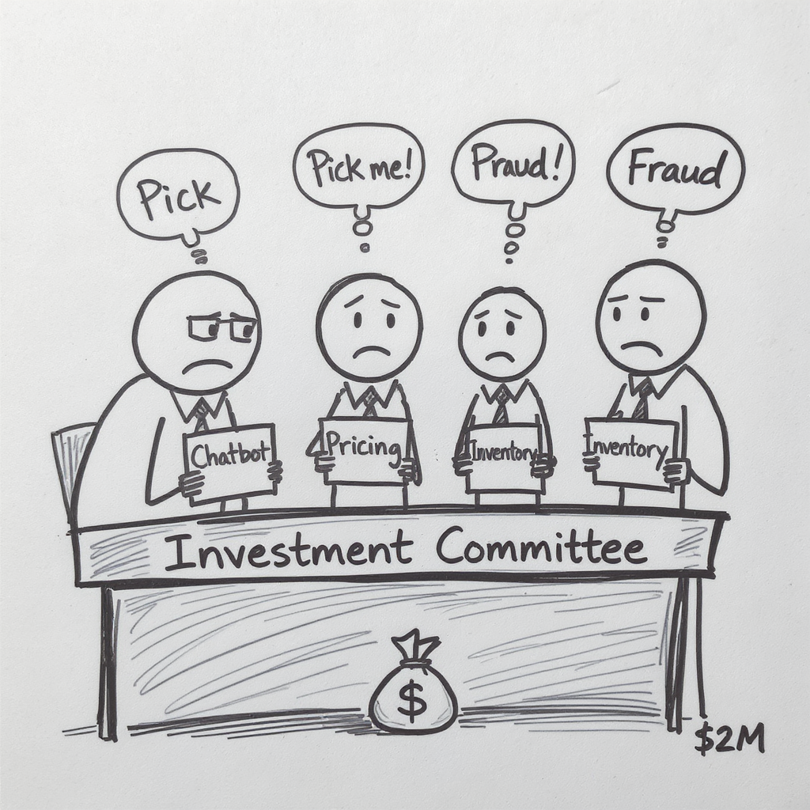
Strategic stress test of the AI Investment Model:
- RetailFlow has $2M budget, $2.95M in requests
- 4 competing initiatives, all with strong ROI
- You cannot fund everything
- The test: Do AI-specific criteria change your decisions?
Your task:
- Project teams: Build investment case using AI criteria
- Investment committee: Evaluate using complete framework

Exercise 4: Strategic Response Scenarios
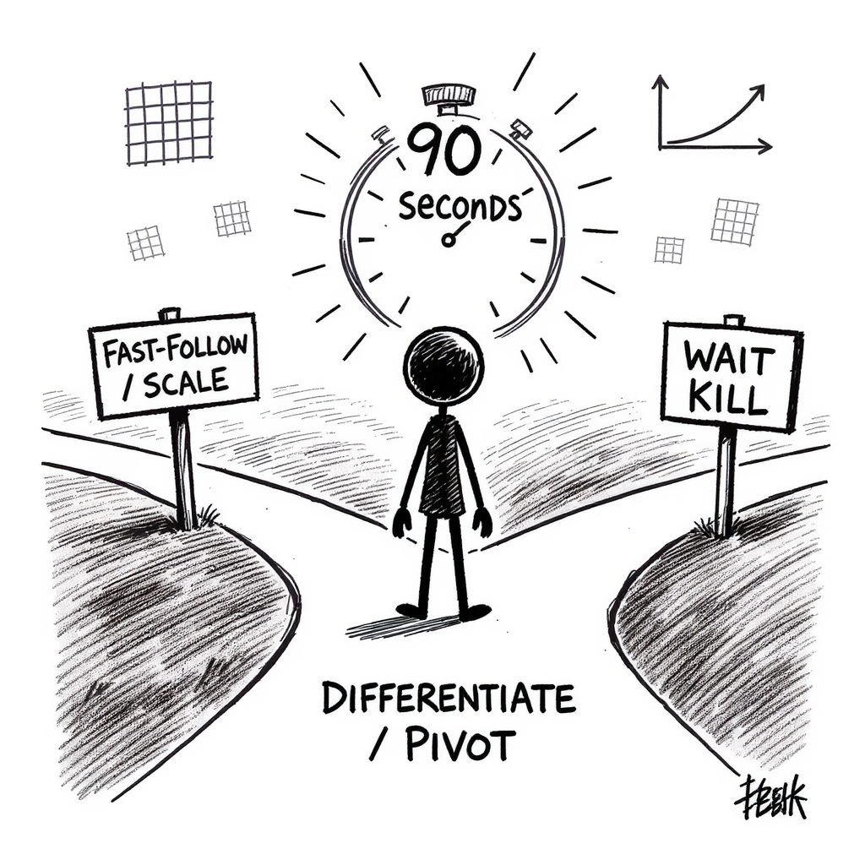
Three rapid-fire strategic decisions with anonymous voting (MS Forms).
Apply frameworks to realistic dilemmas: competitive threats, pilot performance, emerging technology timing.

What You Learned Today

AI investments require DIFFERENT evaluation:
- Data readiness gates everything (6/10 = delay the project)
- Ongoing costs are 3-5x higher (30-50% vs. 10-15%)
- Ethical risks are existential (one biased AI = massive damage)
- Explainability isn’t optional (regulated industries)
- Highest ROI ≠ best investment (must pass AI criteria too)

The Monday Morning Test
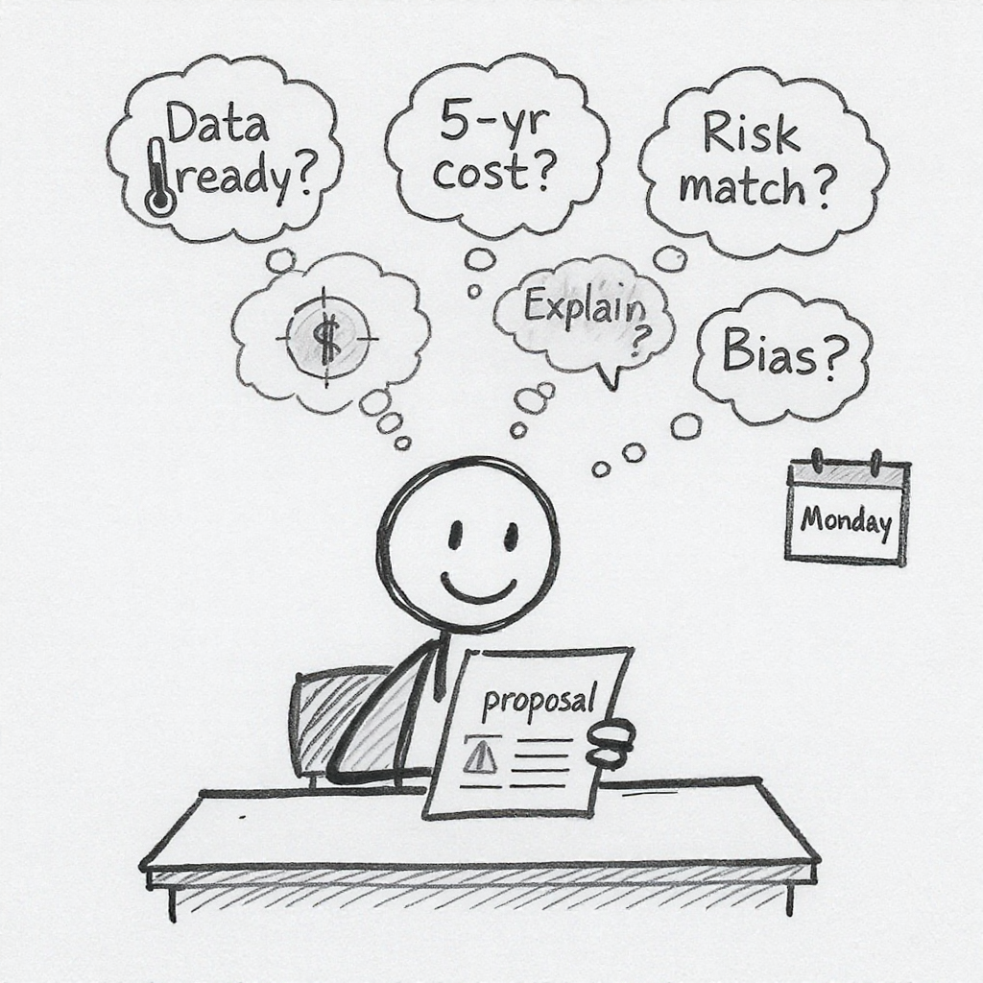
Next AI proposal you see, ask these 5 questions:
- What’s our data readiness score? (0-10, need ≥7)
- What’s the 5-year TCO? (not just Year 1 build cost)
- What’s the cost of being wrong? (accuracy requirement)
- Must we explain AI decisions? (regulatory/trust)
- Could this discriminate? (bias testing plan)
If they can’t answer all 5, you’re not ready to approve
This is your new governance standard.

The 5 Frameworks: Summary
Framework 1: AI Transformation Matrix - Portfolio balance
Framework 2: Data Value Pyramid - Match AI to data maturity
Framework 3: Three Horizons Model - Balance across timeframes
Framework 4: Innovation Adoption - Organizational readiness
Framework 5: AI Investment Model - Traditional + AI-specific criteria

Thank You
Please take the survey

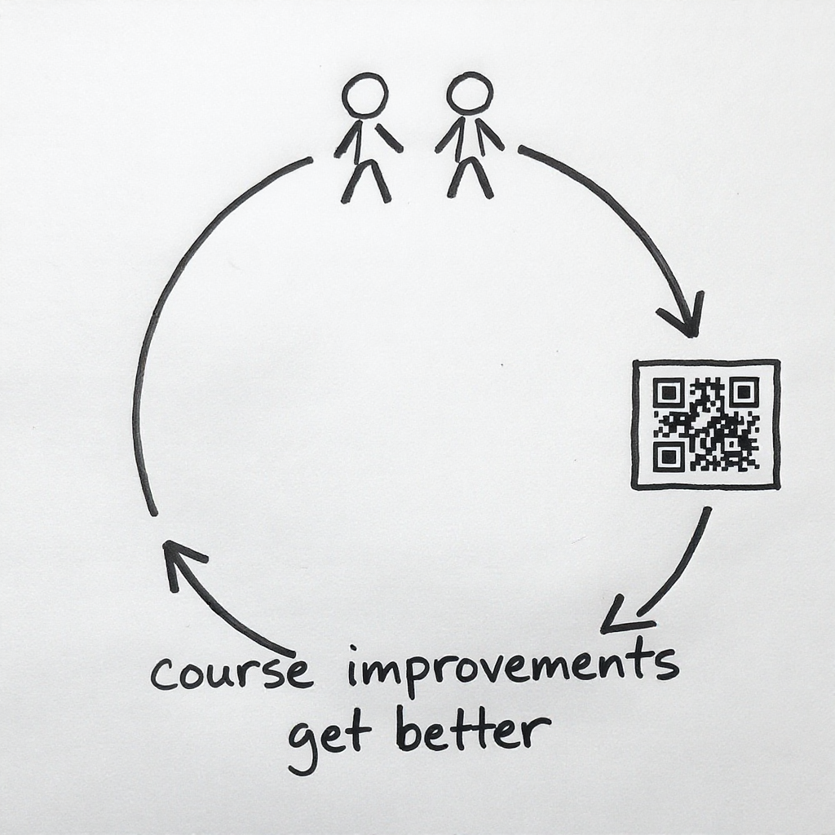
Contact: michael.borck@curtin.edu.au
Materials: https://exec-ed.github.io/ai-business-innovation/
You now have:
- ✅ 5 strategic frameworks
- ✅ AI Investment Checklist
- ✅ Understanding of what makes AI different
Use them Monday morning.

